CLDV6212 POE PART 2

MODULE NAME: Cloud Development B

Module Code: CLDV6212

NAME: Keketso

SURNAME: Mphuti

Student Number: ST10445280

Contents
CLDV6212 POE PART 2 1
MODULE NAME: Cloud Development B 1
Module Code: CLDV6212 1
NAME: Keketso 1
SURNAME: Mphuti 1
Student Number: ST10445280 1
Question A: 3
Screenshots: 3
Question B: 12
Question C: 13
Question D: 14
URLs: 15
References: 16

Question A:
Reasons why it is important to have a replica database:
- It can assist with balancing the load and optimizing performance for ABC Retailers. This means that if there are many orders coming in the and the primary database struggles to keep track of it all, the secondary database will step in to take some of the load. This avoids latency and stress on the database during busy shopping periods.
- Having a replica database strengthens the data protection and adds another back up recovery for the database if anything goes wrong. The geological replication of the original database will add another wall of protection for the data. If anything happens to the primary database, such as crashes or regional outages then the replica database will be there for easy recovery and backup.
- The last reason is that having a replica database can allow extra protection testing for ABC Retail. This means that they can test different protection strategies on the replica database without hurting the primary one.

Screenshots:
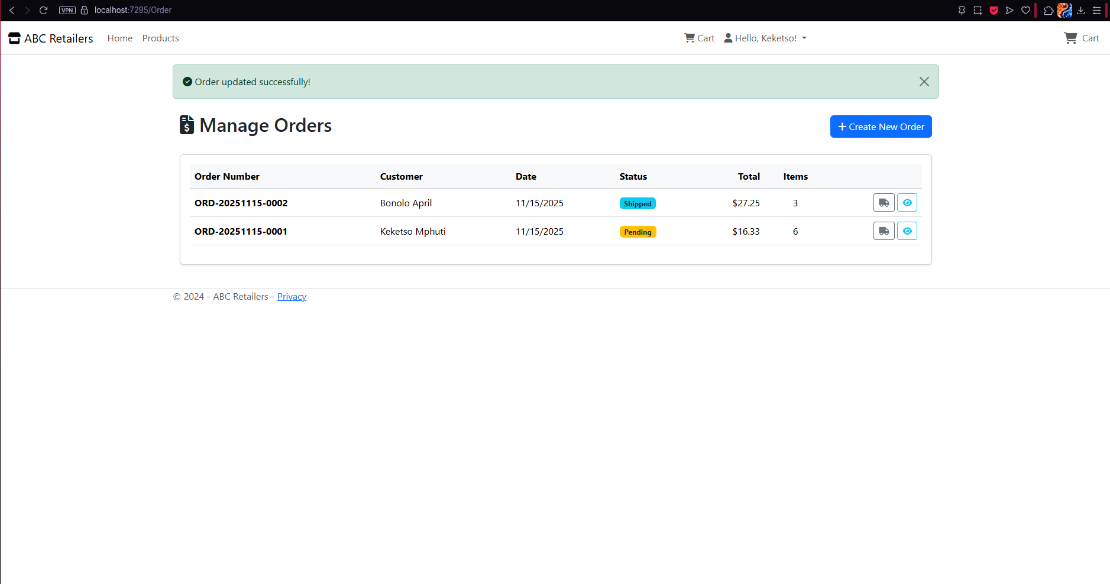
Orders View in Admin perspective:

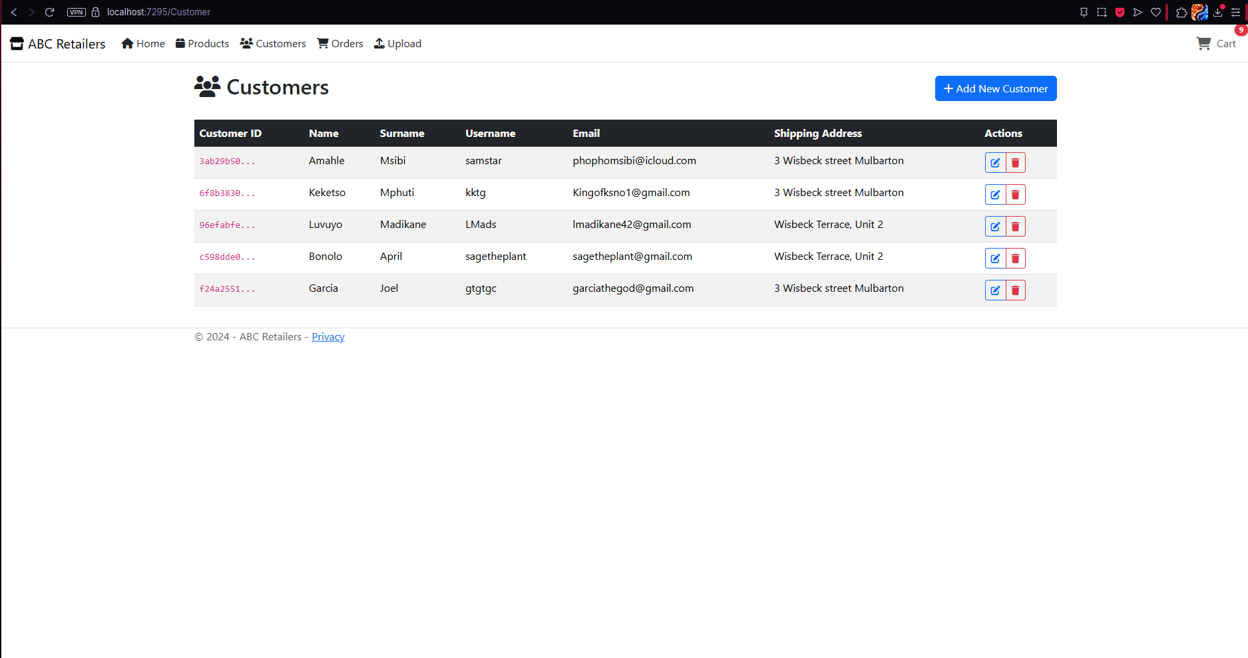
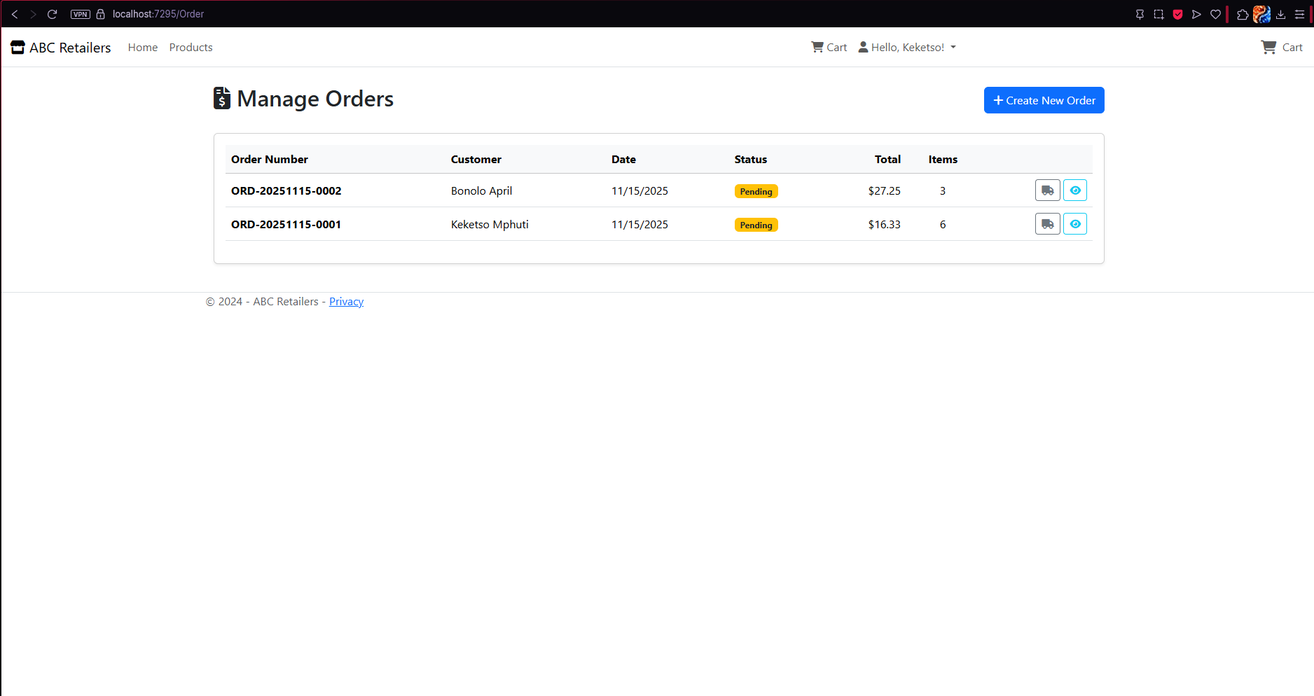
Customer View in Admin perspective:

Products View in Admin perspective:
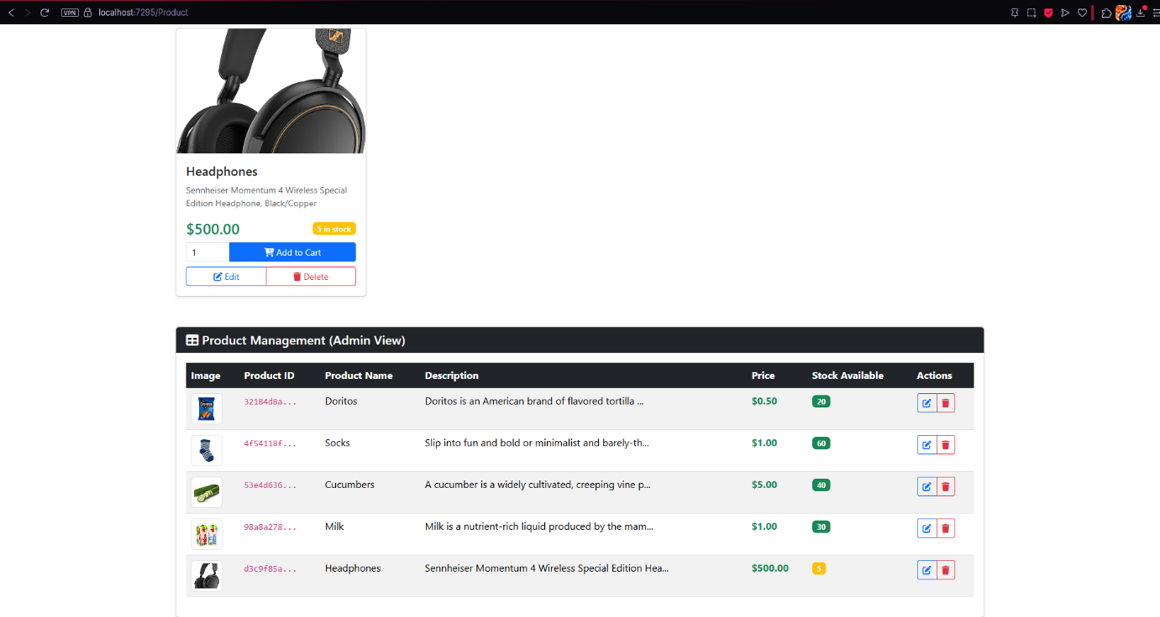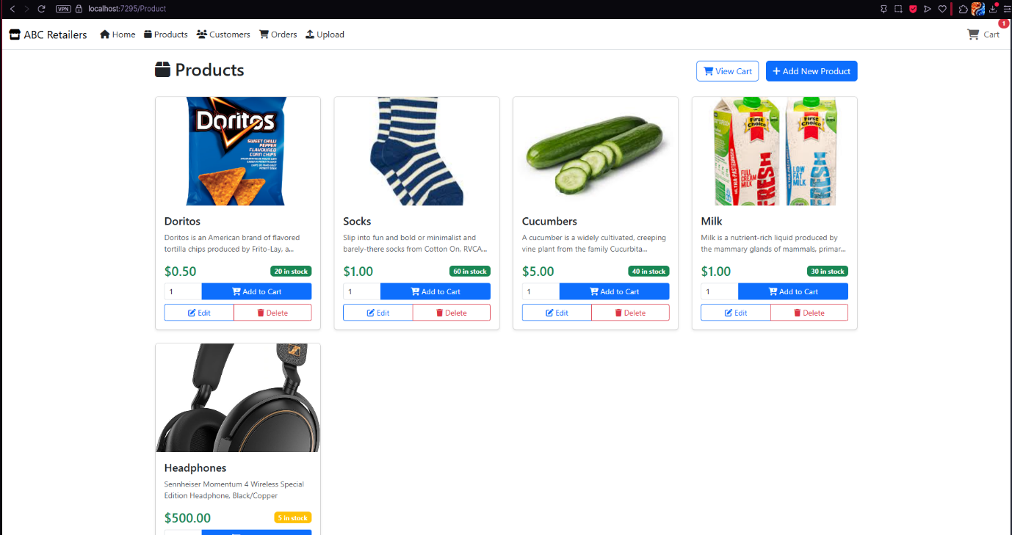

Views in Customer perspective:
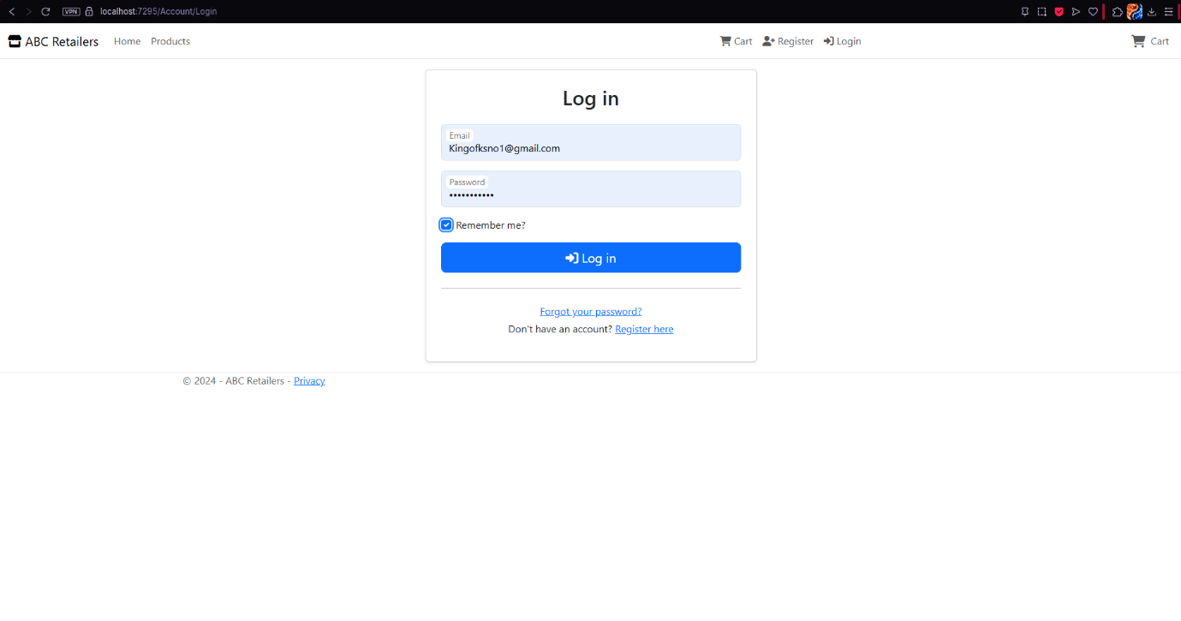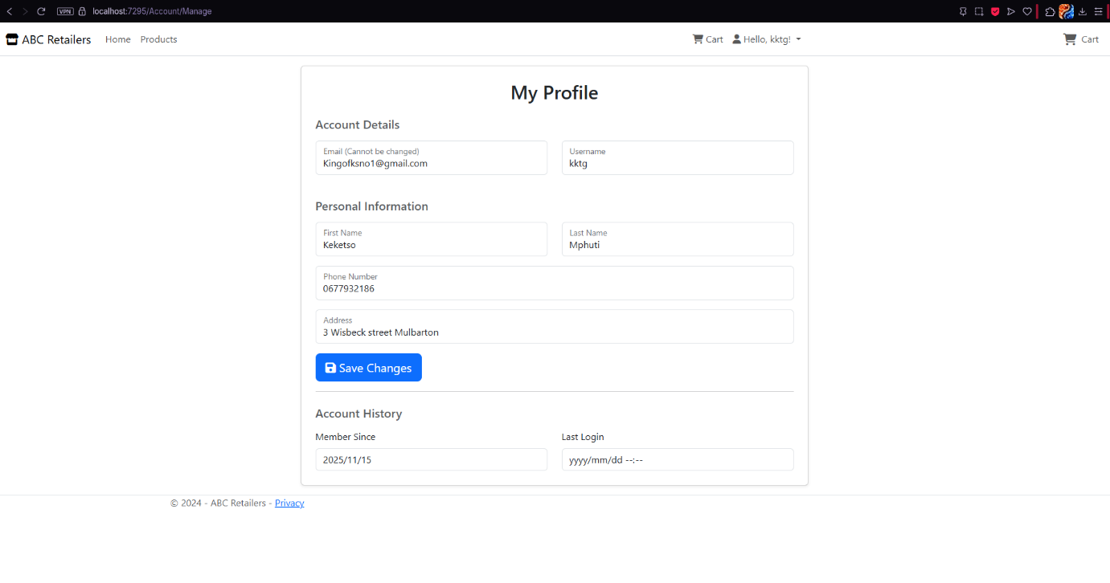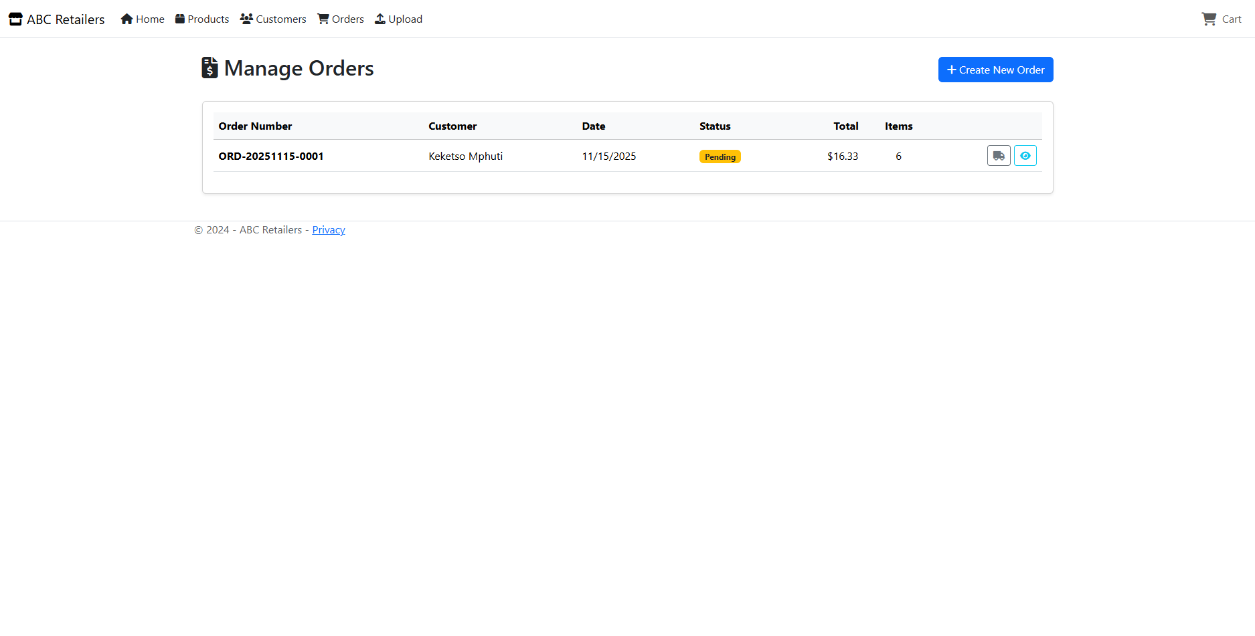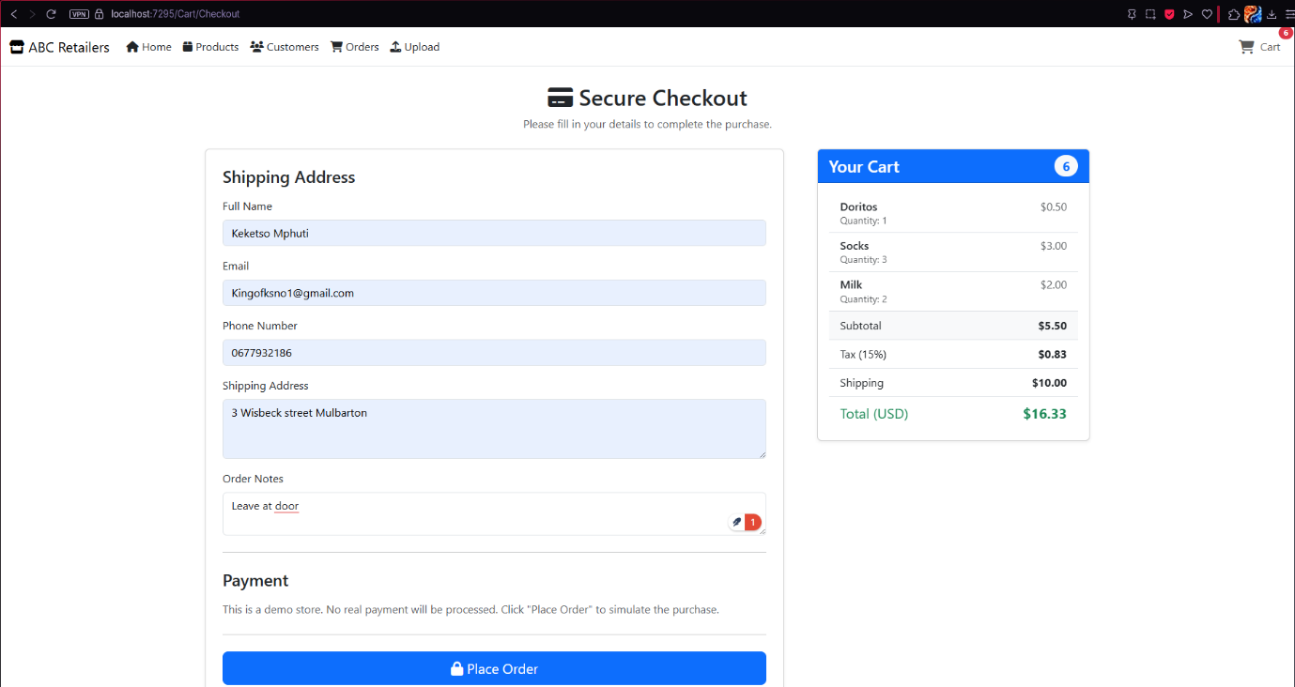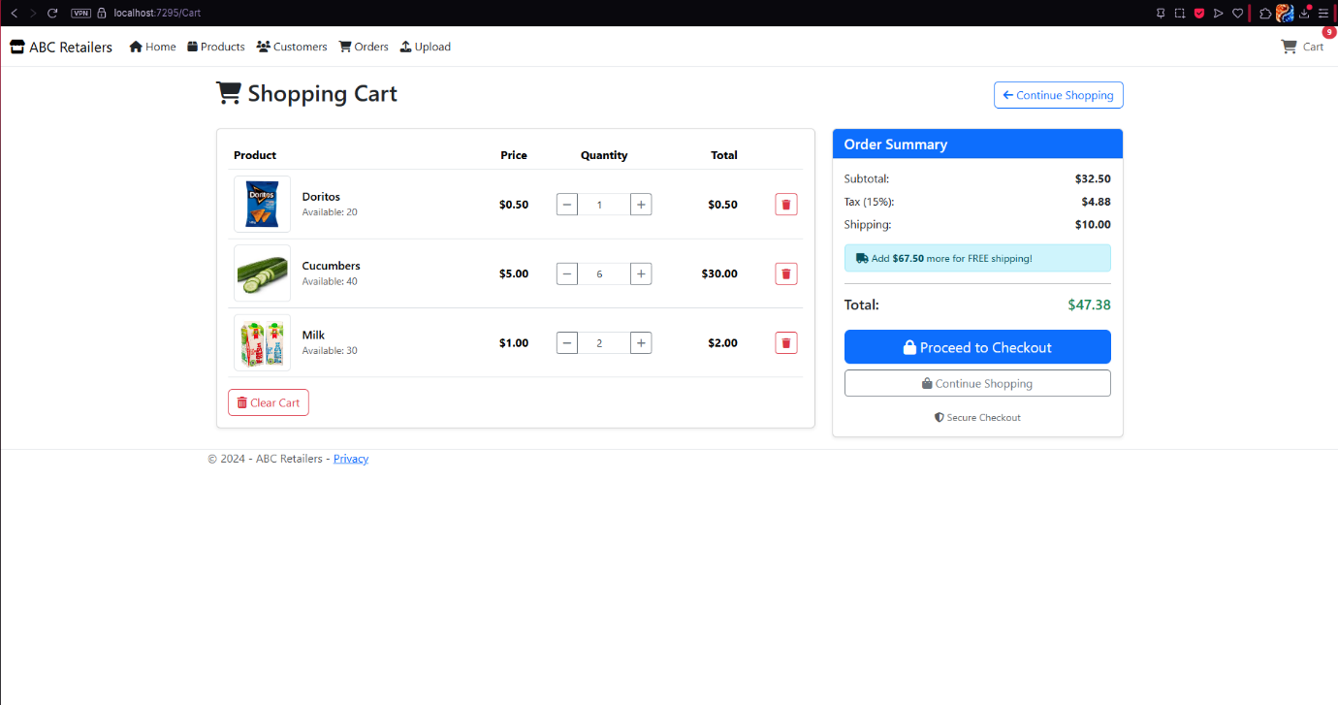
Primary Database:
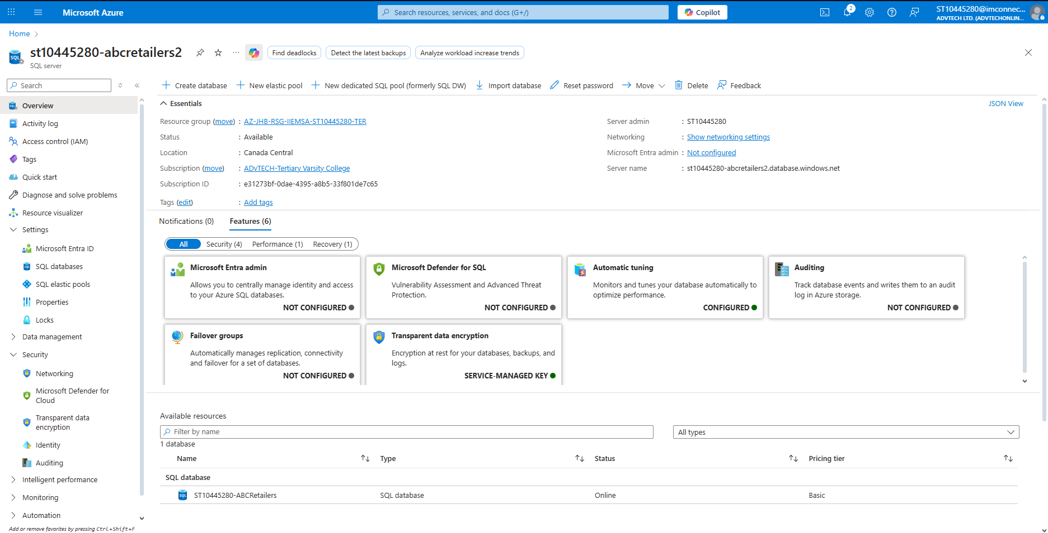
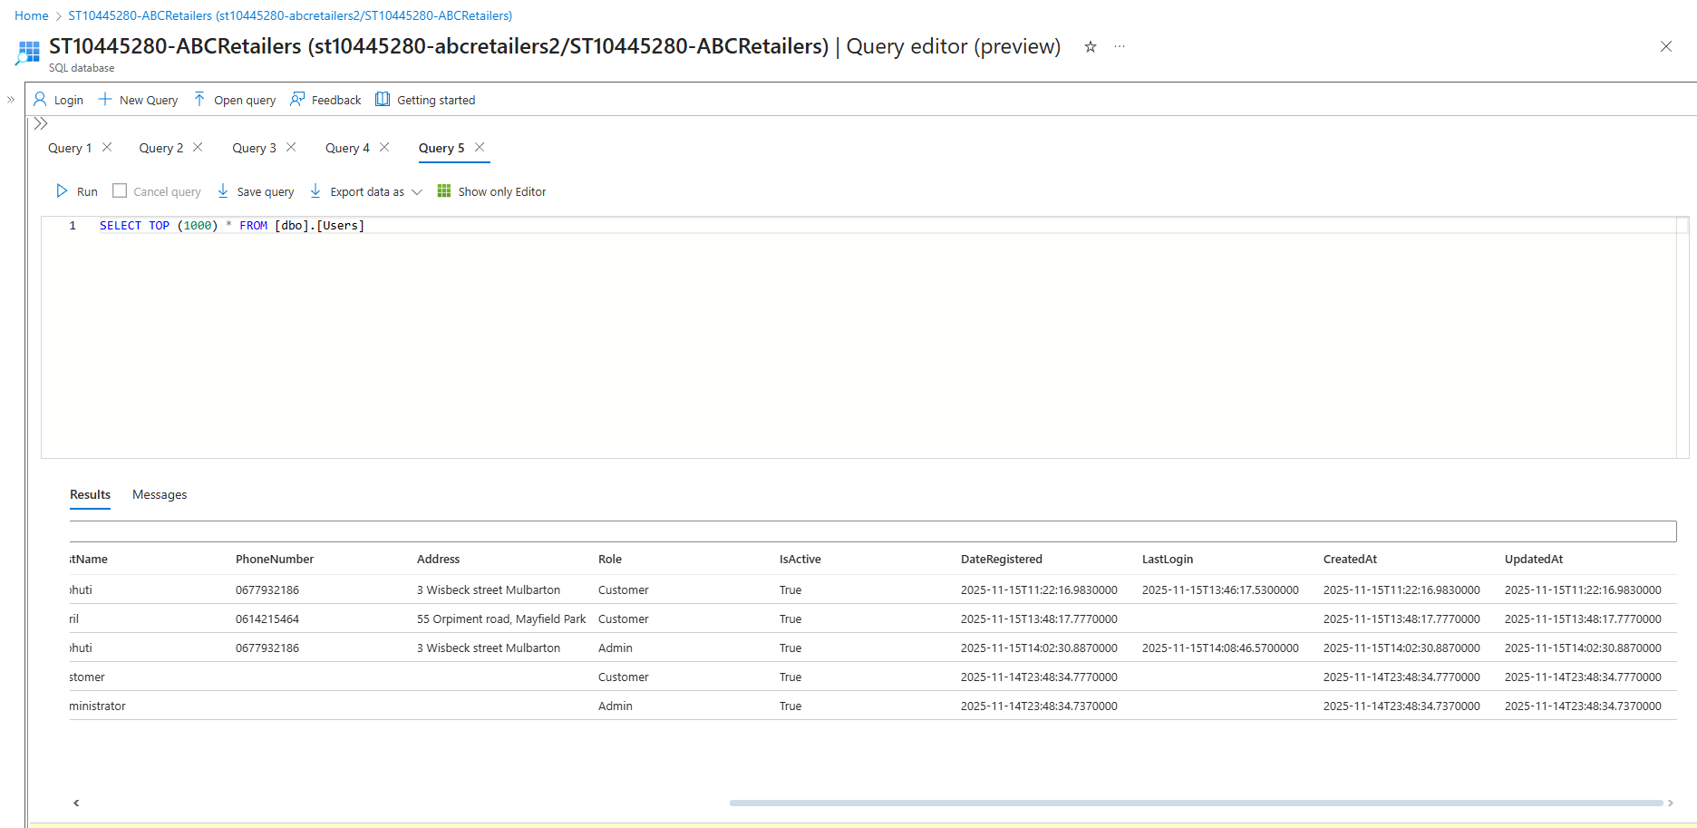
User Table:

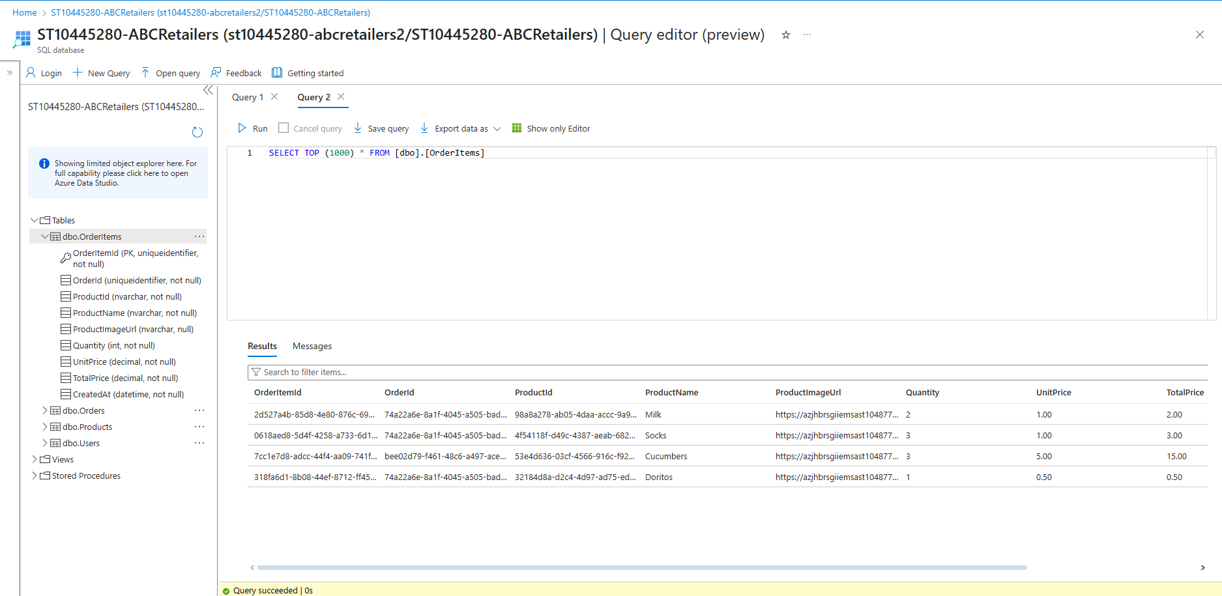
Order Table:

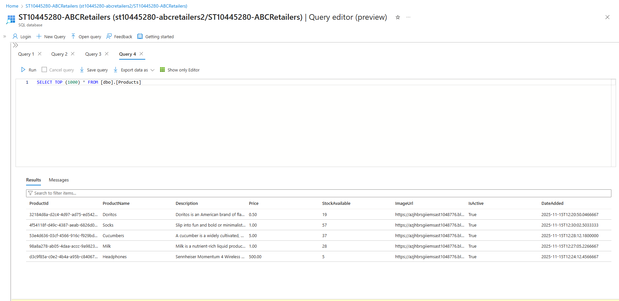
Products Table:

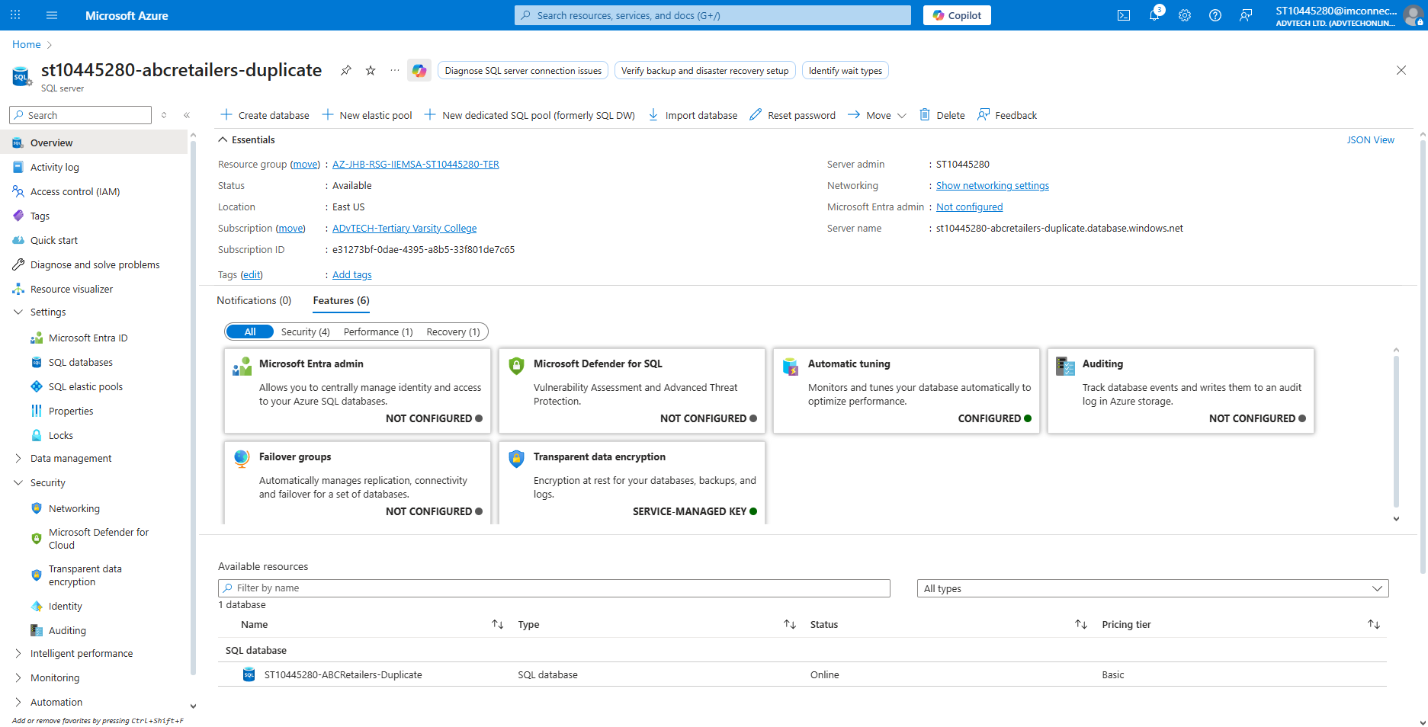
Duplicate Database:
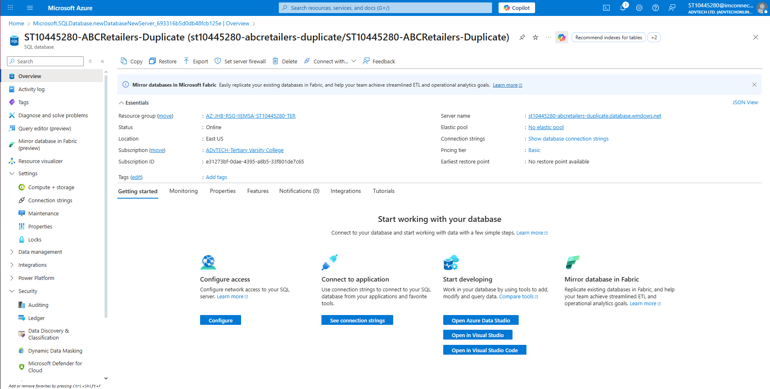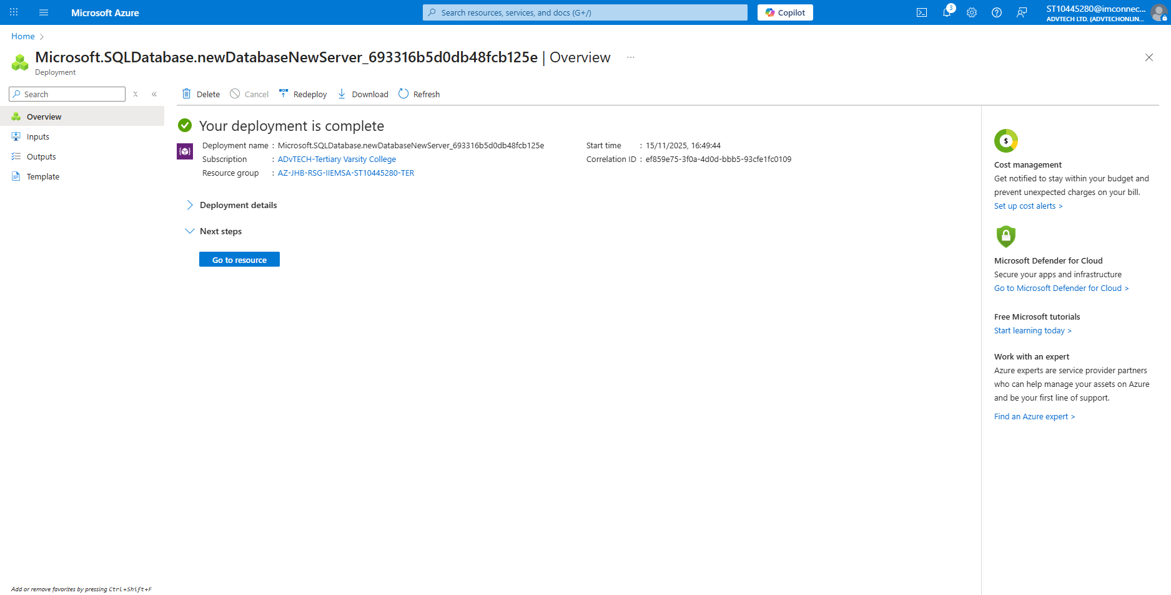

Deployed App

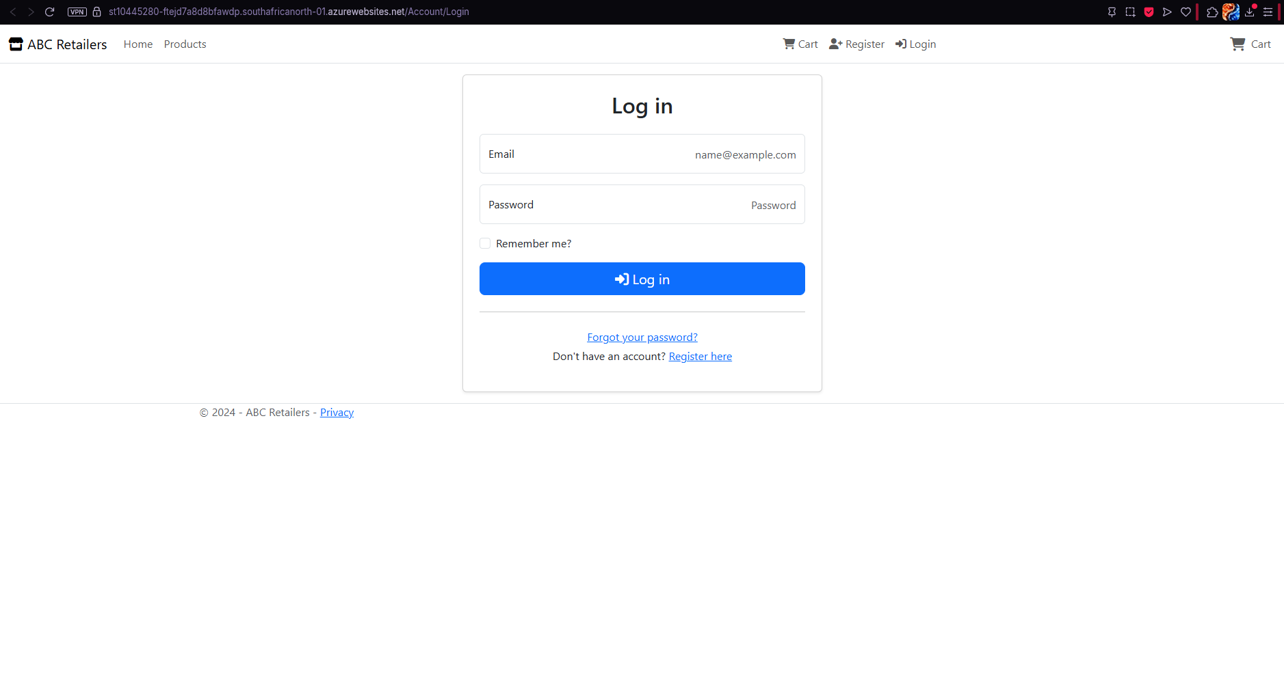

Question B:
Component | Technology Choice | Hosting Model | Description
Azure Tables storage | Data storage | PaaS | NoSQL storage service that provides low-latency access to the structured data.
Azure Blob storage | Data storage | PaaS | Object storage service that stores unstructured media data.
Azure Queue Storage | Messaging | PaaS | Message queuing service that is used as communication between application components.
Azure Functions | Compute | PaaS | An event-driven computing service that will ensure codes  respond to triggers.
Azure SQL Database | Data Storage | PaaS | Fully managed relational database that stores SQL transactional data.
Azure App Service | Hosting | PaaS | Web application hosting platform.
Azure Storage Account | Infrastructure | PaaS | Storage service that hosts Azure blobs, tables and queues.
Azure Event hubs | Event streaming | PaaS | Data streaming platform that can receive and process many events each second.

Question C:
Application Requirement | Azure Service | Motivation
Store Customer Profiles and product information | Azure Table Storage | The table storage automatically handles huge amounts of data per second, and this allows it to have low latency when there are peak shopping periods.
Host Product Images | Azure Blob Storage | The blob storage is designed for images, and the storage can provide high bandwidth while the same image is being looked at by many customers at once.
Process orders and manage inventory | Azure Queue storage | The queue storage will catch every order message and any messages that have errors or won’t process will automatically be sent to a poison message handling to avoid extra latency.
Execute the event-driven processing logic | Azure functions | The functions allow triggers to be used, and when they are used, the data is sent to the Azure storage.
Storing transactional data | Azure SQL Database | The SQL database helps with structuring the data and keeping it safe.
Hosting the web application | Azure App Service | The service allows the application to run even when many users are on the app at once.

Question D:
Azure service | Alternative | Motivation
Azure Table Storage | Azure Cosmos DB | Cosmos DB would let the system run across multiple regions, while Table Storage can only run in one region. This means Cosmos DB could give better global performance and availability.
Azure Queue Storage | Azure Service Bus Queues | Service Bus has smarter features, like detecting duplicate messages and removing them. This helps keep the system cleaner and avoids processing the same message twice.
Azure Blob storage | Azure Data Lake Storage Gen2 | Data Lake Gen2 gives you real folders and directory structures. This makes it easier for ABC Retail to organise product images into clear folders like /products/electronics/laptops.
Azure App Service | Azure container apps | Container Apps can scale automatically based on events from other Azure services. This helps when the app gets busy, because it can add more container instances to handle the extra work.

URLs:
GitHub repository: https://github.com/MphutiKeketso/ST104452280-CLDV6212-POE-Part-3.git
Web App URL: https://st10445280-ftejd7a8d8bfawdp.southafricanorth-01.azurewebsites.net

References:
- DigitalOcean. (n.d.). DigitalOcean. Available at: https://www.digitalocean.com/
- Microsoft. (n.d.). Azure products. Available at: https://azure.microsoft.com/en-us/products
- Microsoft. (n.d.). Microsoft Azure. Available at: https://azure.microsoft.com/
- Microsoft. (n.d.). Introduction to Azure Storage. Available at: https://learn.microsoft.com/en-us/azure/storage/common/storage-introduction

